Name _______________________________________________ Date _______________
Functions Algebra I
DO NOW:
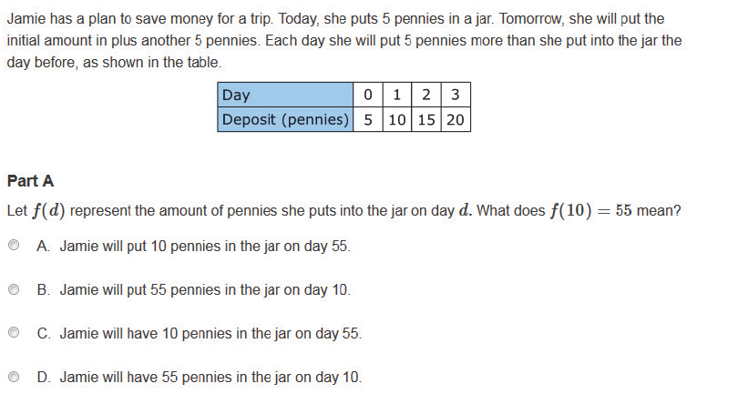

Name _______________________________________________ Date _______________
Functions Algebra I
DO NOW:
Name _______________________________________________ Date _______________
Functions Algebra I
Functions Lesson
h | 0 | 1 | 2 | 3 | 4 | 5 | 6
s | 20 | 26 | 32 | 38 | 44 | 50 | 56

The table shows the amount of ice cream sales, in dollars, recorded at Baskin Robbins h hours after 11AM last Saturday. S is a function of h.
- Using the table, answer the following questions.
  - What variable represents the domain?

  - What does that domain mean in this context?

  - What variable represents range?

  - What does that range mean in this context?

  - What does the $26 mean in the table?

  - What does s(5) mean?
What does s(0) mean?

  - Write an inequality statement that compares s(2) and s(3).

- Let s(h) represent the total sales of Baskin Robbins in a given hour. 11AM represents hour 0, select the statement that is true.

- $s\left(h+1\right)=s(h)$
- $s\left(h+1\right)=6(s\left(h\right))$
- $s\left(h+1\right)=s\left(h\right)+1$
- $s\left(h+1\right)=s\left(h\right)+6$

Name _______________________________________________ Date _______________
Functions Algebra I
Student Practice – Functions

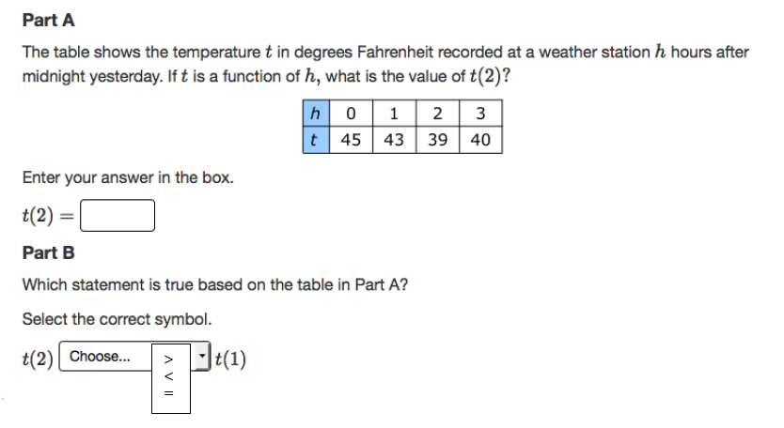
- Two bicycle riders start a race at the same time. The functions f(x) and g(x) give the distance in miles that each rider has traveled after x hours of riding. What does f(2) – g(2) = 5 mean in this context?
  - The riders are 2 miles apart 5 hours after the race starts.
  - The riders are 5 miles apart 2 hours after the race starts.
  - Both riders travel 2 miles in the first 5 hours of the race.
  - Both riders travel 5 miles in the first 2 hours of the race.

- If f is a function and x is an element of its domain, then which of these is correct?
  - f(x) denotes the output corresponding to the input x, and the graph of the function is y=f(x).
  - f(x) denotes the output corresponding to the input x, and the graph of the function is x=f(y).
  - f(x) denotes the input corresponding to the input x, and the graph of the function is y=f(x).
  - f(x) denotes the input corresponding to the input x, and the graph of the function is x=f(y).

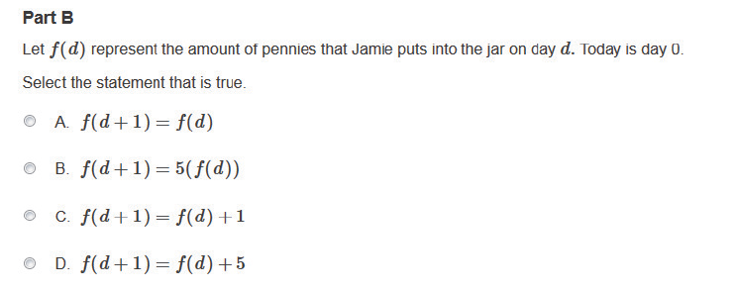

Extension:
The function f(V) represents the amount, in dollars, raised at a fundraiser for a charity by v volunteers.
For each of the following, match the Question Stem to the Answer Choices

Response | Questions |  | Answer Choices
________ | - K is the amount in dollars, raised by 500 volunteers |  | - f(K) = M  - f(M) =K  - f(K) = 500  - f(500) = K
________ | - $500 is the amount, in dollars, raised by K volunteers
________ | - K is the amount, in dollars, raised by M volunteers.

Name _______________________________________________ Date _______________
Functions Algebra I
Exit Ticket:
The table shows the number of poses, p, that a photographer offers with a maximum of 3 poses per shoot.
p | 0 | 1 | 2 | 3
a | 15 | 18 | 21 | 24

Part A) If a is a function of p, what is the value of a(3)?

Part B) Is the following statement true? Explain
$a(0) < a(2)$

Name _______________________________________________ Date _______________
Functions Algebra I
Exit Ticket:
The table shows the number of poses, p, that a photographer offers with a maximum of 3 poses per shoot.
$$p$$ | 0 | 1 | 2 | 3
$$a$$ | 15 | 18 | 21 | 24

Part A) If a is a function of p, what is the value of a(3)?

Part B) Is the following statement true? Explain.
$a(0) < a(2)$

